A101 Instructions for Manuscript Preparation

2nd Report: Subtitle if you need
+Taro REITO*, Hanako KUCHO** and Jiro SHOKUHIN***
*Department of Mechanical Engineering, Yotsuya University, Shinjuku-ku, Tokyo, 160-0008, Japan
**Department of Physics, Shinjuku Institute of Technology, Meguro-ku, Tokyo, 152-0033, Japan
***Department of Chemical Engineering, Sanei University, Shibuya-ku, Tokyo, 151-0053, Japan
Abstract should be written with 10pt Times New Roman and single-space from here. The Number of words is limited within 150.
Please send a Word file (.doc) and PDF(.pdf) file of 2 or 4 pages with A4 size to the organizing committee jsrae10@jsrae.or.jp.
High quality setting is recommended for PDF conversion.
The file size should be less than 2 MB.
Times New Roman is recommended.
Deadline: July 30, Friday
Keywords: Keyword1, Keyword2, Keyword3, Keyword4, Keyword5

Introduction (Top heading should be in bold)
Manuscripts should be made on two or four pages of A4 paper. The main text should be written in two-column format with a font of 10 pt Times. The interval of columns should be 8 mm.

Paper size and Margins
    - Paper size
A4 paper.

Margins
top: 25 mm, bottom: 25 mm
left: 20 mm, right: 20 mm
upper header: 15 mm from top edge of paper
lower footer: 15 mm from bottom edge of paper

Format
Manuscripts should consist of the title, author(s), author’s affiliation and address, abstract, keywords, and main text. Those should be written according to the format given in this template. MS-Word users: please use the heading styles contained in this document.

Author(s)
Please indicate the name of the presenting author with “+” leading the name.

Main text
Main text should begin at two lines bellow keywords.

Heading
For example, the headings in this template are.

Equations
Equations and symbols should be written with 10pt italic font except super/sub scripts. There should be one line space upper and lower equation. In the main text, a equation is explained as Eq.(1).
(1)

Figures and tables
Proceedings will be printed in monochrome. Keep margins. Figures and tables should be explained in main text as Fig.1，Table 1.
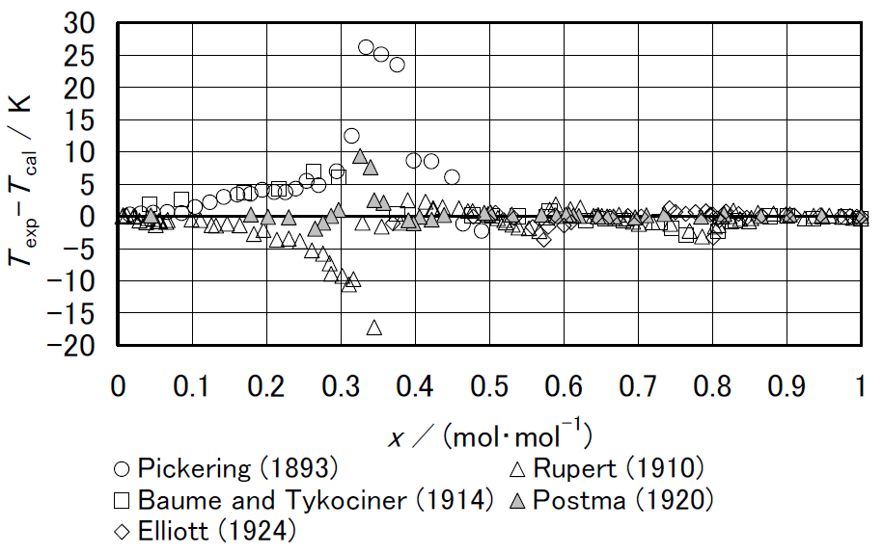
Fig.1 Deviation of measured freezing point temperatures from correlations by Tillner-Roth [2].
Table 1 Historical data of vapor pressure of ammonia.
Author | Year | T | p | Ref.
Keyes | 1918 | 240-398 | 0.103-9.96 | 1
Cragoe | 1920 | 195-343 | 0.00563-3.31 | 25
McKelvey | 1923 | 195-195 | 0.1 | 26
Beattie | 1930 | 303-405 | 1.17-11.3 | 8
Overstreet | 1937 | 176-242 | 0.0008-0.1114 | 27

References
References should be indicated by [1], [2,3], [4-7], and be listed at the end of manuscript. Examples are shown in the next page.

How to submit your manuscript
Please send your manuscript in PDF format to the e-mail address below. The file size should be less than 2 MB.

Yukio TADA
Kanazawa University
E-mail : jsrae10@jsrae.or.jp

Deadline
July 30, 2010

Inquiry
Organiging Committee of 2010 JARAE Annual Conference
jsrae10@jsrae.or.jp

ACKNOWLEDGMENTS
Our thanks to ...

NOMENCLATURE
c_{p} | : specific heat at constant pressure, kJ･kg⁻¹･K⁻¹
F | : Helmholtz function, kJ
G | : Gibbs function, kJ
h | : specific enthalpy, kJ･kg⁻¹
p | : pressure, kPa
T | : temperature, K
t | : Celsius temperature, ℃
V | : volume, m³

REFERENCES
- F.G. Keyes and R.B. Brownlee: J. Am. Chem. Soc., 40(1), 25 (1918).
- R. Tillner-Roth, J. Li, A. Yokozeki, H. Sato and K. Watanabe: “Thermodynamic Properties of Pure and Blended Hydrofluorocarbon (HFC) Refrigerants”, JSRAE, (1997).
- T. Miyazaki and K. Oguchi: Proc. 2001 JSRAE Annual Conf., JSRAE, 181 (2001). (in Japanese)
- Technical report of JSRAE : JSRAE Co., (2010. 4).
- http://www.jsrae.or.jp/ : (2010. 3).

